1. Print the first 10 natural numbers using for loop

**Proge –**

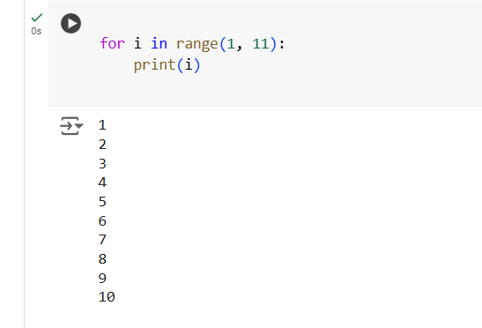

**Output –**



1. Python program to check if the given string is a palindrome

**Prog –**

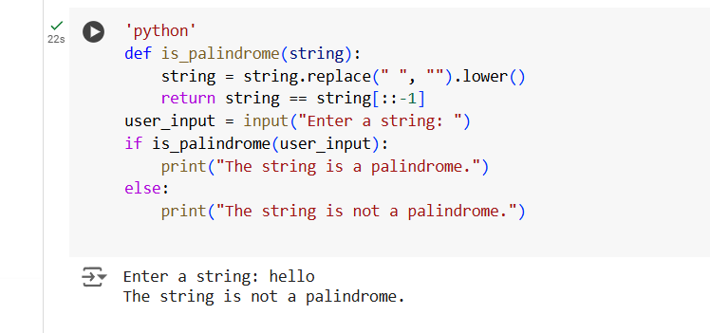

Output –



1. Python program to check if a given number is an Armstrong number

**Prog –**

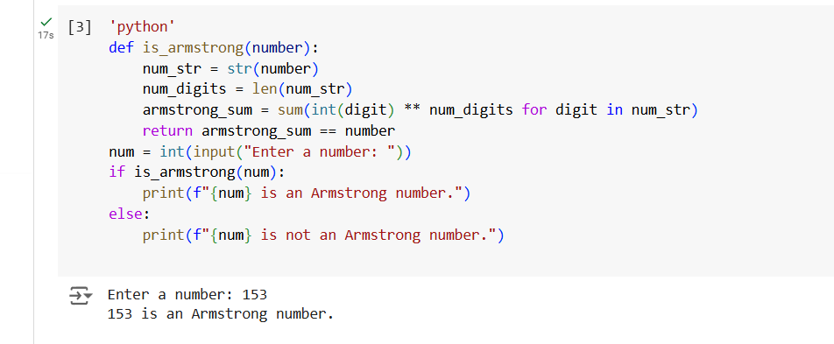

**Output –**



1. Python program to get the Fibonacci series between 0 to 50

**Prog –**

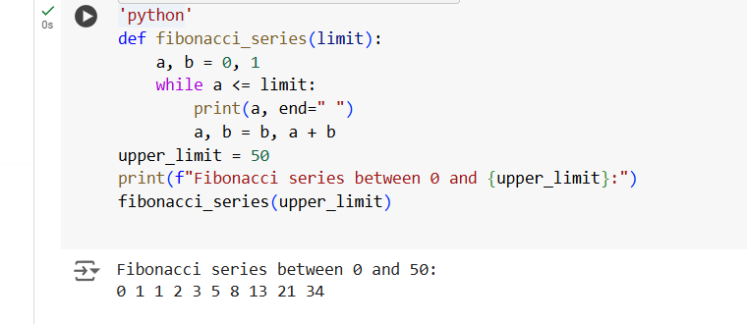

**Output –**



1. Python program to check the validity of password input by users

**Prog** –

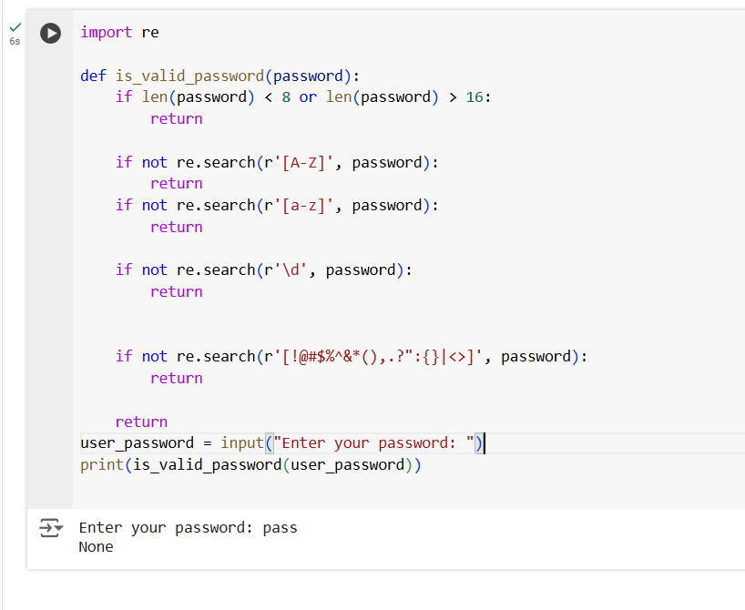

**Output –**